EX NO | UX DESIGN FOR SHOPPING APP
DATE | UX DESIGN FOR SHOPPING APP

AIM
My aim in this project is to model and document the full cycle of an e-commerce mobile application interface, as designed in Figma. I sought to establish a clear, documented path for a user's core action: making a purchase.

ALGROITHM

1 open the application. The flow starts with the Splash Screen and moves immediately to the Login/Signup Screen. Accessibility: I prioritized social login for fast entry.
2 choose one of my linked Google accounts. I am taken directly to the Home Screen, which features categorized browsing elements. Efficiency: I bypassed manual credentials for a quick start to shopping.
3| I select a category (e.g., Men) and view the products. The Product Listing Page (PLP) appears, displaying items, prices, and discounts.Clarity: I ensure product details (Bestseller tags, price, discount) are immediately visible.
4 I select a product and tap to add it to the bag. I transition to the Bag/Cart Screen, showing the item, quantity, and detailed price breakup. Transparency: I highlight savings and the final payable amount before checkout.
5 tap "Proceed to Payment". | I move to the address selection step. Since I need a new location, I tap "Add New Address". | User Control: I provide a clear path to manage and update delivery details.
6 I fill out all the fields for contact and address information. | The Add Address Screen prompts for Name, Pincode, Flat No./Building Name, and Address Type. | Completeness: I ensured all required logistical information is collected efficiently. |
7 I tap "Save Address". | The address is saved (implied payment screen follows), and I can then access the My Account Screen via the bottom navigation. | Navigation: I provide access to orders, coupons, and wallet features after the purchase flow. |

HOME SCREEN

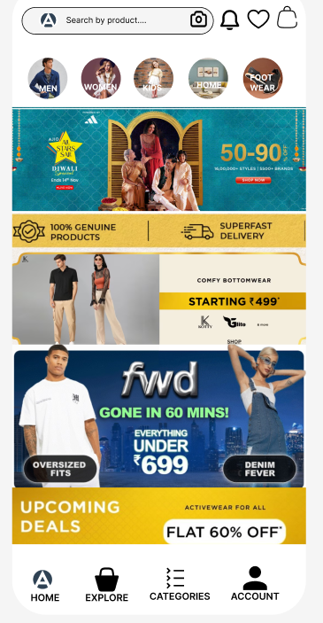

USER PROFILE


SETTINGS
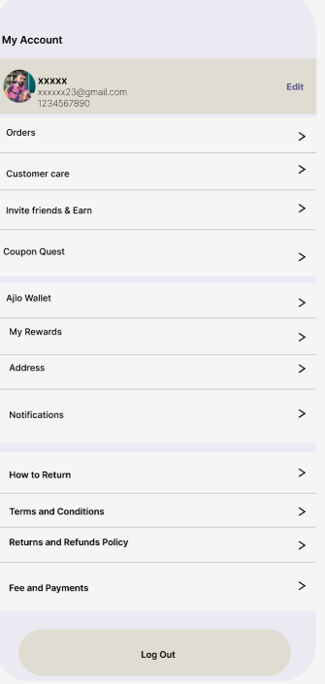

PRODUCT FEED
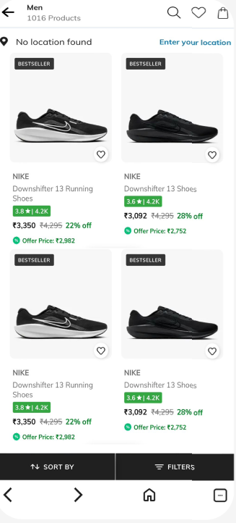

SEARCH

PRODUCT DETAILS
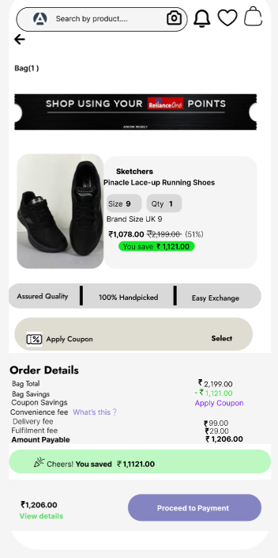

RESULT
The UX design works well and is easy for users to understand.
Users can search, view products, and navigate the app smoothly.

